**Flight Reservation System**

**Project Description:** In this system users are allowed to look for, book and cancel flights using this system. The administrator is able to add and delete destinations change prices and so on. The registered users are able to search for flights, and book or cancel flights.

The database is containing the description of flights, the booking information and personal information of passengers.

In this system users are of three types one is registered passengers, guest users and admin.

**Complete E-R Diagram:**

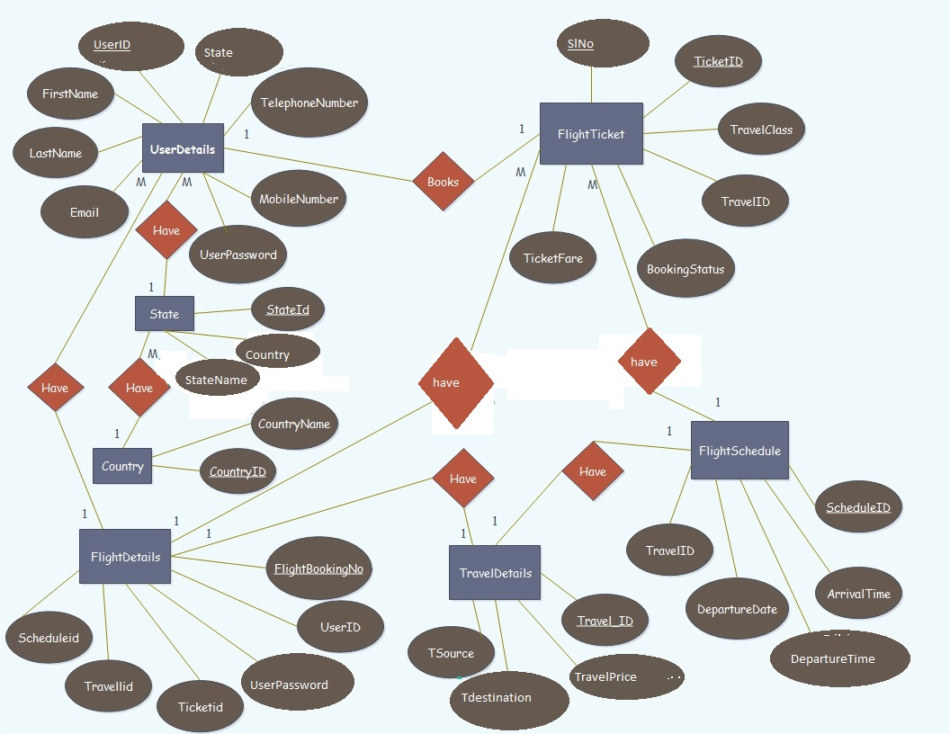

**Complete Data Base Schema Diagram:**

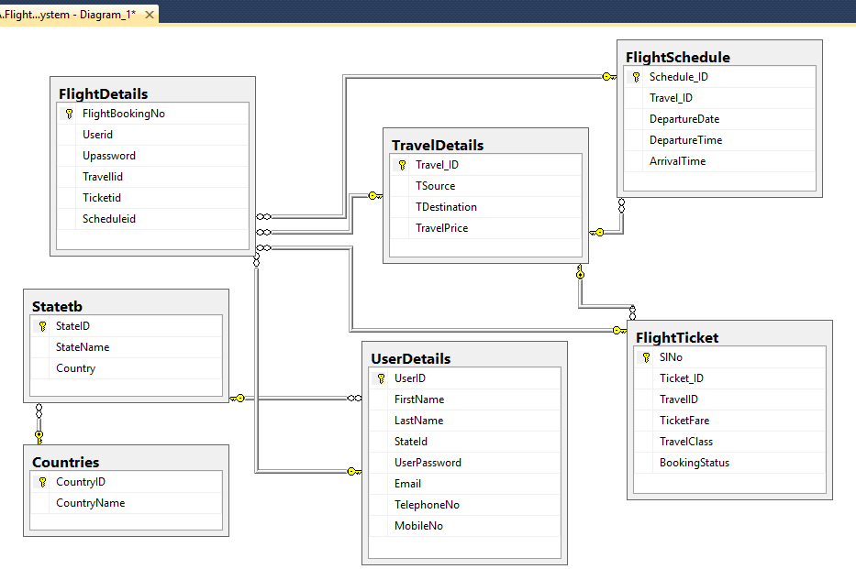

**SQL Statements used to manage the Data Base:**

**Creation of Tables and Insertion of Values: TravelDetails Table:**

CREATE TABLE TravelDetails(Travel_ID int PRIMARY KEY, TSource varchar(100) NOT NULL,

TDestination varchar(100) NOT NULL, TravelPrice Money NOT NULL);

INSERT INTO TravelDetails(Travel_ID,TSource,TDestination,TravelPrice)

VALUES (1,'California','Texas',350),

(2,'California','Florida',250),

(3,'Kentucky','Michigan',300),

(4,'Arizona','Alabama',450),

(5,'Ohio','Colorado',400);

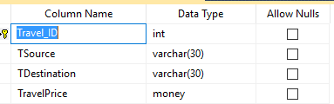

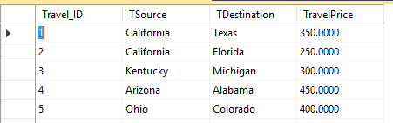

**FlightScheduleTable:**

CREATE TABLE FlightSchedule(Schedule_ID INT,Travel_ID INT NOT NULL,DepartureDate DATE NOT NULL,

DepartureTime Time NOT NULL,ArrivalTime Time NOT NULL,

PRIMARY KEY (Schedule_ID),

CONSTRAINT fk_Travel_ID FOREIGN KEY (Travel_ID) REFERENCES TravelDetails(Travel_ID));

INSERT INTO FlightSchedule(Schedule_ID,Travel_ID,DepartureDate,DepartureTime,ArrivalTime)

VALUES (1,2,'May 15,2016','6:00','7:40'),

(2,1,'June 16,2016','10:00','13:10'),

(3,4,'May 16,2016','7:00','9:00'),

(4,5,'May 15,2016','8:00','10:50'),

(5,3,'July 20,2016','20:00','23:30');

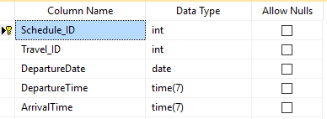

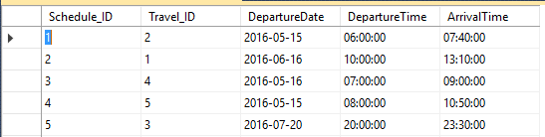

**FlightTicket Table:**

CREATE TABLE FlightTicket(SlNo INT,Ticket_ID varchar(50) NOT NULL UNIQUE,TravelID INT NOT NULL,

TicketFare Money NOT NULL,TravelClass Varchar(50) NOT NULL,BookingStatus BIT NOT NULL

PRIMARY KEY (SlNo),

CONSTRAINT fk_TravelID FOREIGN KEY (TravelID) REFERENCES TravelDetails(Travel_ID));

INSERT INTO FlightTicket(SlNo,Ticket_ID,TravelID,TicketFare,TravelClass,BookingStatus)

VALUES (1,'Sw001',2,225,'Economy',1),

(2,'Sw002',4,450,'Economy',1);

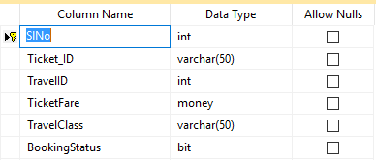

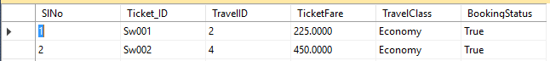

**Countries Table:**

CREATE TABLE Countries(CountryID INT PRIMARY KEY,

CountryName varchar(50) NOT NULL);

INSERT INTO Countries(CountryID,CountryName)

VALUES (1,'India'),

(2,'Germany'),

(3,'USA'),

(4,'UK'),

(5,'Australia');

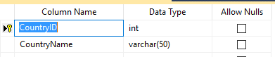

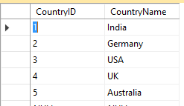

**Statetb Table:**

CREATE TABLE Statetb(StateID INT,

StateName varchar(50) NOT NULL,

Country INT,

PRIMARY KEY(StateID),

CONSTRAINT fk_Country FOREIGN KEY (Country) REFERENCES Countries(CountryID));

INSERT INTO Statetb(StateID,StateName,Country)

VALUES (1,'Missouri',3),

(2,'Nevada',3),

(3,'Texas',3),

(4,'Mumbai',1),

(5,'Sydney',5);

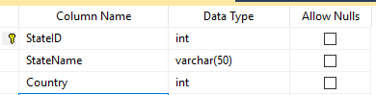

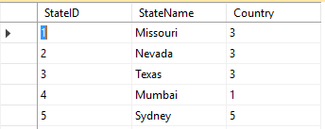

**UserDetails Table:**

CREATE TABLE UserDetails(UserID INT,

FirstName varchar(50) NOT NULL,

LastName varchar(50),

StateId INT,

UserPassword nvarchar(100) NOT NULL,

Email varchar(50),

TelephoneNo varchar(50),

MobileNo varchar(50),

PRIMARY KEY(UserID),

CONSTRAINT fk_StateId FOREIGN KEY(StateId) REFERENCES Statetb(StateID));

INSERT INTO UserDetails(UserID,FirstName,LastName,StateId,UserPassword,Email,TelephoneNo,MobileNo)

VALUES (501,'Derrick','Hill',1,'treat@004','hill@gmail.com',0011475643,9988776655),

(502,'swathi','',4,'catch@554','random@gmail.com',112879678,8978675645);

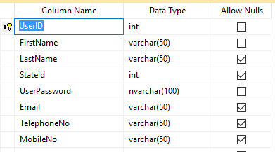



**FlightDetails Table:**

CREATE TABLE FlightDetails(FlightBookingNo INT,

Userid INT NOT NULL,

Upassword nvarchar(100) NOT NULL,

Travellid INT,

Ticketid VARCHAR(50),

Scheduleid INT,

PRIMARY KEY(FlightBookingNo),

CONSTRAINT fk_Userid FOREIGN KEY (Userid) REFERENCES UserDetails(UserID),

CONSTRAINT fk_Travellid FOREIGN KEY (Travellid) REFERENCES TravelDetails(Travel_ID),

CONSTRAINT fk_Ticketid FOREIGN KEY (Ticketid) REFERENCES FlightTicket(Ticket_ID),

CONSTRAINT fk_Scheduleid FOREIGN KEY (Scheduleid) REFERENCES FlightSchedule(Schedule_ID));

INSERT INTO FlightDetails(FlightBookingNo,Userid,Upassword,Travellid,Ticketid,Scheduleid)

VALUES (100,501,'treat@004',2,'Sw001',1),

(101,502,'catch@554',4,'Sw002',3);

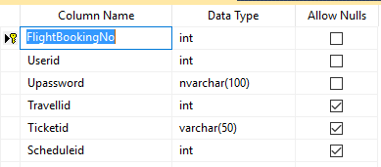

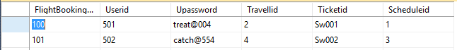

**Updating Records:**

UPDATE UserDetails

SET Email='updated@gmail.com', MobileNo=9999999988 where UserID=502;

select * from UserDetails where email='updated@gmail.com'

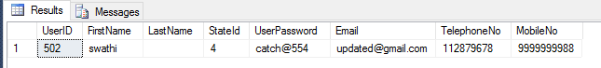

**Deleting Records:**

DELETE FROM FlightSchedule

WHERE Schedule_ID=5;

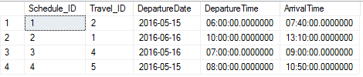

**Retreiving Records:**

The below query retrieve the records using correlated query concept.

select u.firstname from UserDetails as u where u.UserID IN (SELECT F.Userid FROM FlightDetails F WHERE F.FlightBookingNo=100)

